Read Me

Requirements:
Flask==1.1.1
gunicorn==19.9.0
numpy>=1.9.2
scipy>=0.15.1
pandas>=0.19
matplotlib>=1.4.3
seaborn>=0.10.0
scikit-learn>=0.18
pip install nltk\
Doc String Queries:
- python app.py
  - After running this, a http URL with IP address will get generated in the command prompt. That should be copied and pasted in the browser window.
- Python book.py
  - Runs the training, feature engineering and also displays a set of sample recommendations when an input book name or User ID is provided.
- Sample Book Names that can be used (Case-sensitive so please copy paste):
  - To Kill a Mockingbird
  - The Chamber
  - 1984
- Sample User ID’s and Passwords that can be used:
  - User ID: 11676 Password: Gayu123
  - User ID: 164533 Password: Keerthi456
  - User ID: 171118 Password: Deep789
Index for the Attached Files:
Please refer to the below list for information about all the attached files:
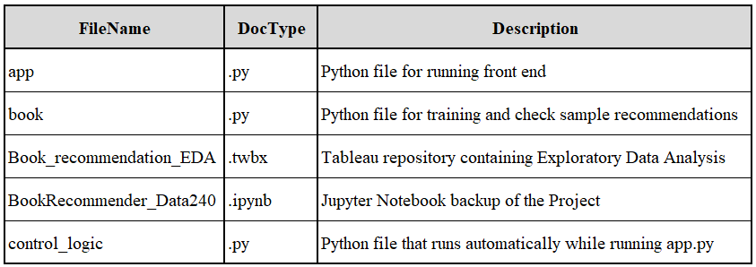

Data folder contains the source used to run the front end, Static folder contains images used while developing UI and Template folder contains the HTML pages and templates.
Source Data Link :
The dataset used can be found in the below link:
http://www2.informatik.uni-freiburg.de/~cziegler/BX/
The front-end runs using the pre-processed data, stored in the data folder.

